Module 1: Introduction

Tom Carruthers, Adrian Hordyk

# Exercise 1: Online Demonstration

## Introduction

In this exercise you will explore the online demo of DLMtool. The demo was built using an application called R Shiny, which allows users to explore pre-run MSEs with a user-friendly online interface without having to type any R code.

The online demo is useful for building an understanding of the MSE process, and having a first look at building operating models, selecting performance metrics, and examing trade-offs among alternative management strategies.

It is an extremely watered-down version of the full R package which is considerably more powerful and customizable.

All results here are for demonstration purposes only.

## Data-Limited Toolkit Website

The online demo is available on the [Data Limited Toolkit](http://www.datalimitedtoolkit.org) website. Head to <http://www.datalimitedtoolkit.org/demo> in your web browser and click the 'Start the Demo' button. It may take a few seconds for the application to load.

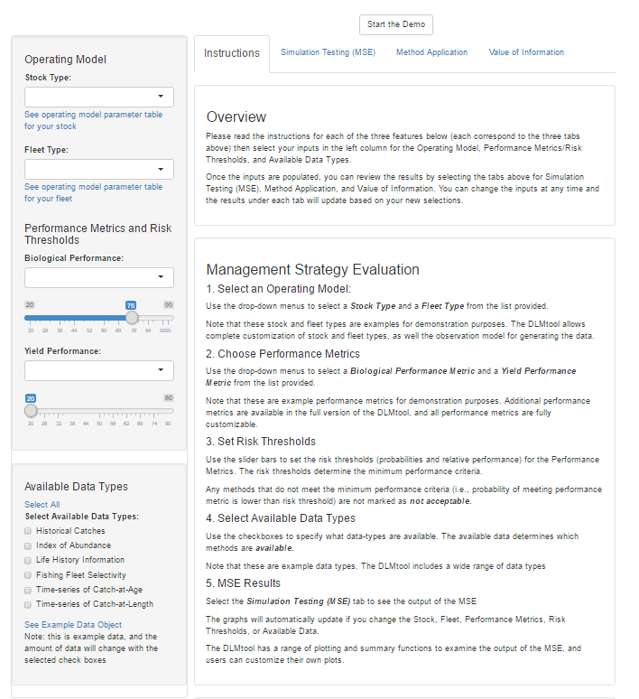

Screenshot of the DLMtool Online Demo

## 

## Scenario 1

### Operating Model

Select Stock Type **Sole** and Fleet Type **Stable Effort**.

### Performance Metrics

An **Acceptable** MP must have at least 70% probability of $B>0.5B_{MSY}$ and an expected long-term yield of at least 50% of that expected from fishing perfectly at $F_{MSY}$.

### Available Data Types

The available data types are **Historical Catches** and an **Index of Abundance**.

### Questions

* Identify a Management Procedure from the Trade-Off plot that you think is the best candidate for managing the fishery. Why do you think this is the best available method?
* How does the method perform in terms of **Short-Term Yield**?
* Examine the trade-offs among the best performing methods with respect to Short and Long-Term Yield. Why do some MPs have high short-term yield but relatively low long-term yield? You can look at the projection plots of the different methods to compare the performance of two MPs over time.
* If the method you've identified as the best candidate is not currently available, what additional data are required?
* How does the performance of this method change under conditions of increasing fishing effort?

## 

## Scenario 2

### Operating Model

Select Stock Type **Blue Shark** and Fleet Type **Stable Effort**.

### Performance Metrics

In this example you will be examining the performance of two specific MPs:

1. **AvC:** the TAC is the average of historical annual catches
2. **MCD:** the TAC is the average of historical annual catches with an additional adjustment for depletion: TAC = AvC * 2 * Depletion

Select the ‘Simulation Testing (MSE)’ tab and scroll down to the Section labelled ‘Fishing Mortality (F/FMSY) and Biomass Projections (B/BMSY) for the Best-Performing Methods’

Here you can select AvC and MCD and compare the projection trajectories of B/BMSY and F/FMSY (the red-yellow-green line plots).

### Available Data Types

Select all data types.

### Questions

* Looking at the projection lines plots that show F/FMSY and B/BMSY, which of the two MPs has the highest propensity to overfish?
* Which simulations are more likely to lead to overfishing using the AvC MP (clue: can you see a pattern in the color of the lines and their position)?
* Can you explain this pattern and also explain why it is not as pronounced for the MCD MP?

## 

## Scenario 3

### Operating Model

Select Stock Type **Albacore** and Fleet Type **Stable Effort & Targeting Small Fish**.

### Performance Metrics

An **Acceptable** MP must have at least 80% probability of $B>0.5B_{MSY}$ and an expected long-term yield of at least 50% of that expected from fishing perfectly at $F_{MSY}$.

### Questions

* Identify the best performing method with respect to these performance metrics. What data are required in order for this MP to be Available?
* What method would you select if all data types were available? What additional data are required to unlock this MP?
* If you know something about this MP, consider the assumptions of the method and whether they are likely to hold in a data-limited fishery. You may be able to use the DLMtool documentation to find more information on the MP.
* The *ItargetE4* method appears to have high probability that biomass is above $0.5B_{MSY}$ but relatively low expected yield compared to other methods. Can you explain this performance trade-off?